**THE CIRRUS GROUP**

[**http://www.thecirrusgroupllc.net**](http://www.thecirrusgroupllc.net)

**NEW FEATURE – AVAILABLE SUPPLIER DATABASE FILTER**

**Overview**

My company, The Cirrus Group, is a network consultancy and procurement company for data network products, services, applications, and ancillary support products, such as software, hardware, and consumables, like toner and paper.

We represent a list of over 520 suppliers, ranging from Tier 1 ubiquitous suppliers (like AT&T, Verizon, Xerox, and IBM) to niche and boutique providers (like 01T, 365 Data Centers, and MetTel). There is literally not a telecom network and services provider we are not contracted with to provide off retail pricing below market.

We approach clients and offer to do a network analysis and recommendation for how their network can be optimized for performance and/or efficiency. If the client elects to move forward, they purchase their services through us as the Channel Partner of the selected supplier.

Often, at engagement, the client has a provider (or a list of preferred providers) in mind they would like to purchase form, and they want to ensure we can offer services from the desired provider. As 520+ (and growing) providers is an extensive list to search through, I decided that a database of each provider, with each attribute product type they offer associated, would be something that could be searchable for the user to generate a short list of options from which to peruse.

So, very similar to the Google Calendar feature offered as a final project option, this feature option will allow me to demonstrate that I can write a code to filter data elements and pull only those desired to be seen, based on a set of attributes. In completing this exercise, I am simultaneously able to enhance the usability of my existing website (with screenshots below), which I can then personally maintain as suppliers and associated offered products change over time.

Because my website is done in PHP, with the Atom editor (a development of GitHub), I was unable to adapt Flask/Pycharm for this feature development without sacrificing the look and feel of the site, which I wanted to preserve. I therefore had to use PHP and the Atom IDE to develop this, with XAMPP as the simplified “container” in which to run the test code.

The output you see here meets with the needs of the site, and I am pleased with the appearance and functionality of the result. I will continue to use this table/filter option after this class is over.

The information shared in this exercise is clearly proprietary and not meant to be shared outside of the teacher/TA/student relationship. Not for use or disclosure elsewhere.

**THE CIRRUS GROUP - LANDING PAGE:**

I am showing you the highlights of the website, so you can get a feel for the context of the information in which the new feature will function. This is the landing page, that gives (on a scroll) the top six advantages of doing business with The Cirrus Group:

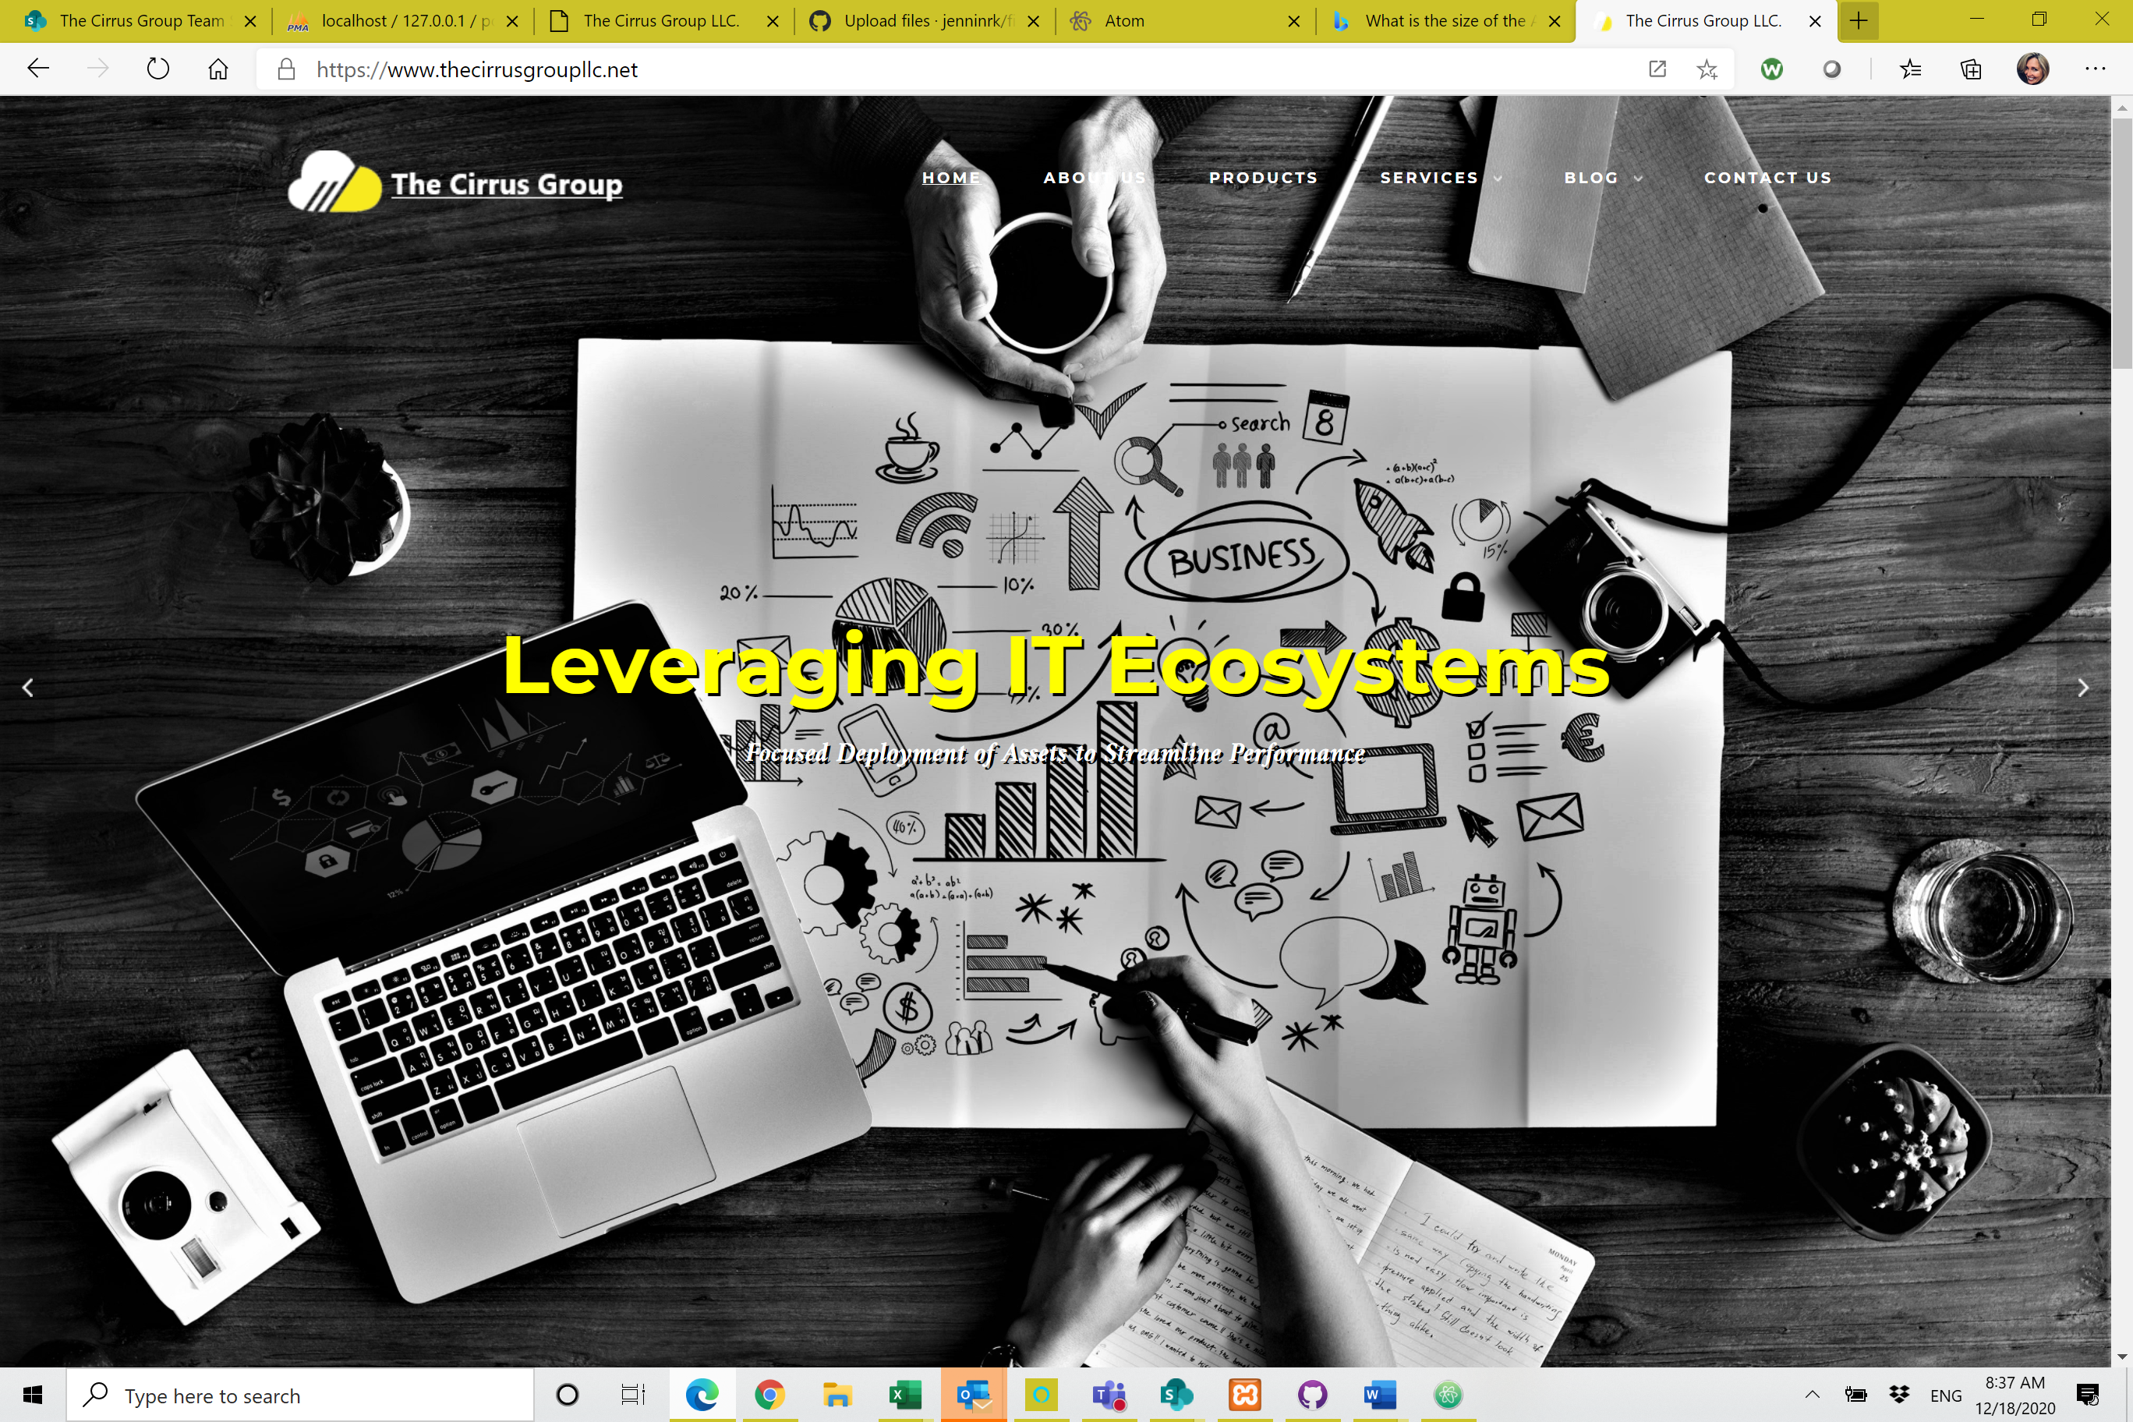

**ABOUT US**

This page goes into some deeper detail regarding services returned, and gives a glimpse into what clients can expect in the way of deliverables and value add.

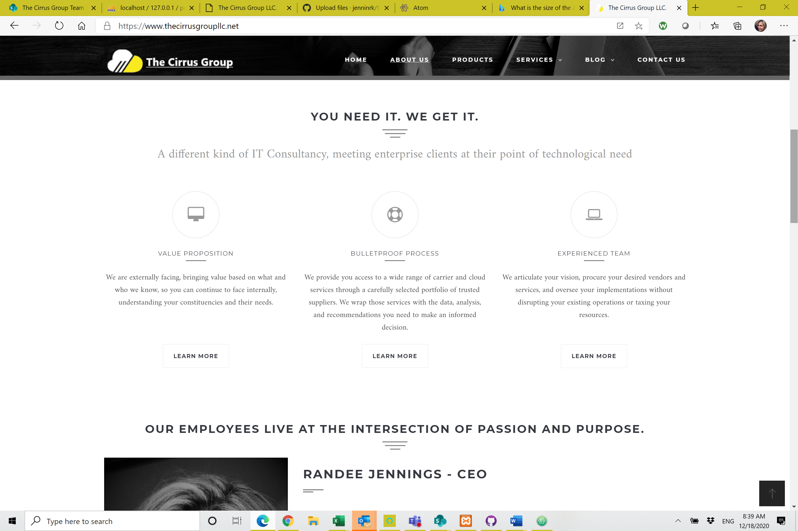

**OUR TEAM**

Since our key offers include:

(1) The knowledge and experience of our team members, who are well qualified to evaluate and recommend optimal solutions, and;

(2) The products and services we can procure,

…we felt it was essential to both lay out the experience of the team, and the suppliers and products available.

Here we list our employees with a brief bio and experience list, to offer assurance that the rep the prospective client will be dealing with is well equipped to handle a network of any size or complexity.

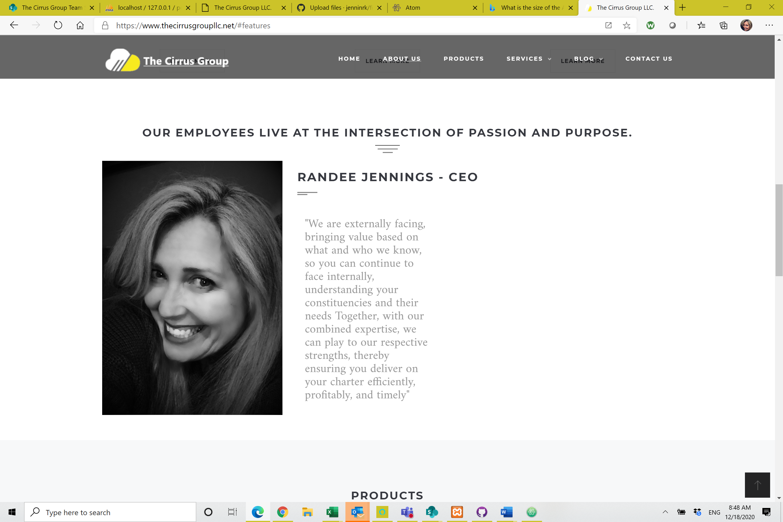

**PRODUCTS**

Here we lay out the product categories available, again so the prospective client can see we can care for virtually any product need they may have, in every available product set, and from virtually any supplier available in the marketplace today.

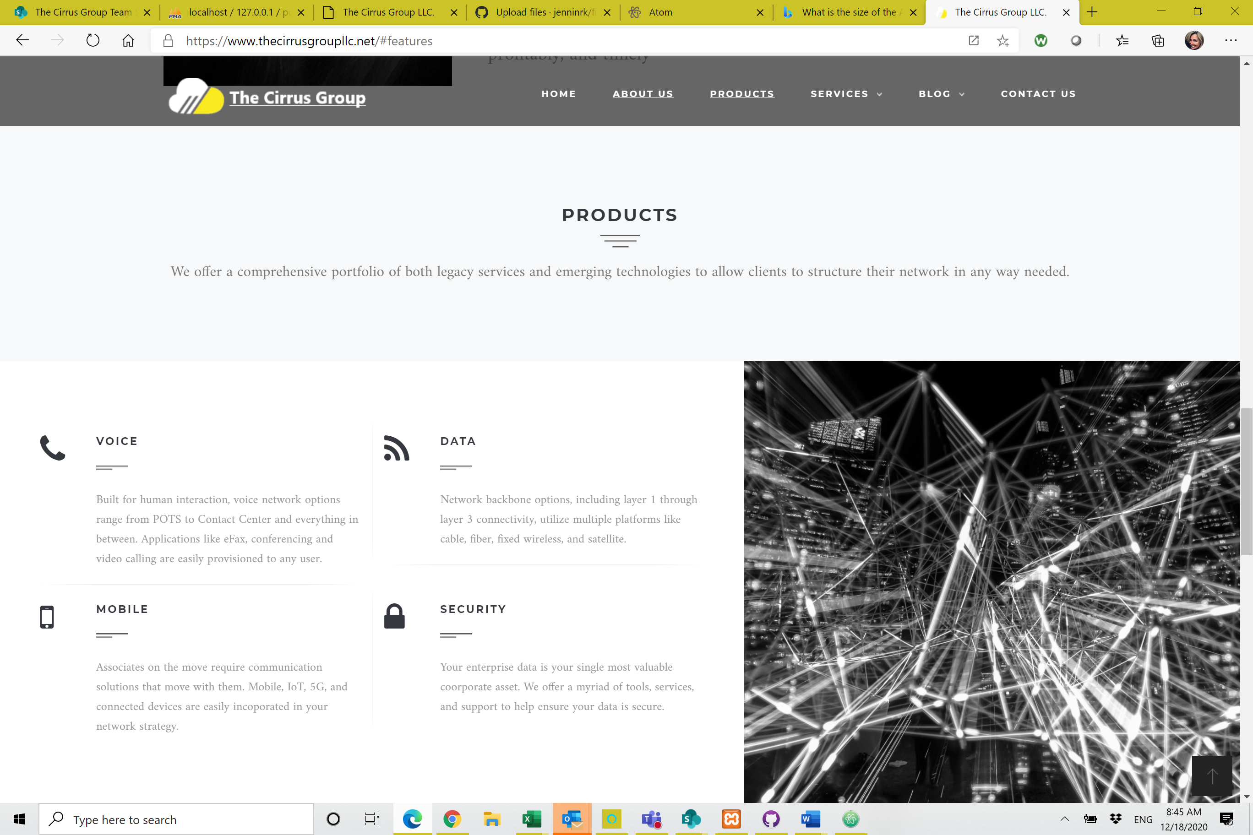

**AVAILABLE SUPPLIER MATRIX – THIS IS THE FINAL PRODUCT FEATURE ADDED**

This is a cut of the total available supplier list.

Each supplier has a list of six attributes (i.e., Voice, Data, Wireless/Mobile, Software, Hardware, and Infrastructure), which are the products they offer at a category level. Notice “Filter Selected” under Filter Drop Down Box is currently set to “All””.

Site visitors who are interested in seeing the available suppliers we represent for the product they are interested in, would click on the drop down box, containing a list of each of the six attributes. They would select the attribute they are interested in (i.e., Data), and the site will return the list of available suppliers who have data as an available product category. They would then see the website URL for that supplier, and that supplier’s logo.

Because the suppliers list – though it contains all suppliers, - has not been fully articulated with all the attributes of each. For this reason this feature is not released into production yet, but will be made available in January 2021.

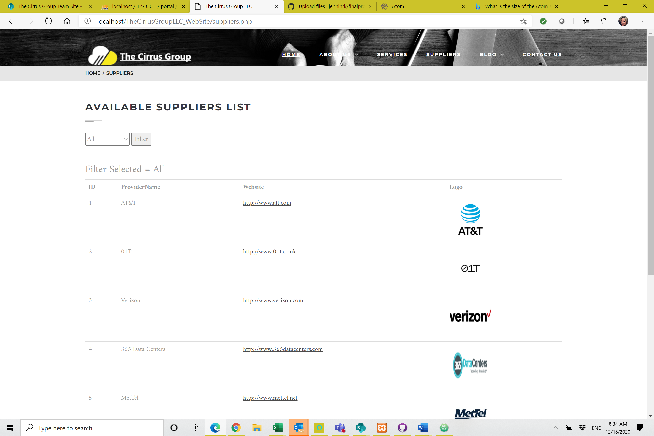

**AVAILABLE SUPPLIER MATRIX – DRILL DOWN FOR DATA SUPPLIERS**

In this screen shot, we selected “Data” as an attribute option, and pressed return. The elements returned represent the list of suppliers who have a “Yes” in the data column, meaning they offer data services.

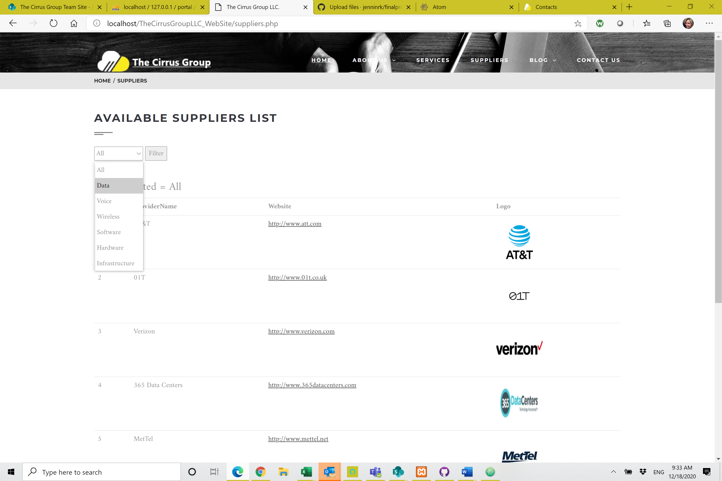

**AVAILABLE SUPPLIER MATRIX – LIST OF DATA SUPPLIERS RETURNED**

This shows the list of Data Suppliers post filter. Notice the “Filter Selected” section is now equal to “Data”

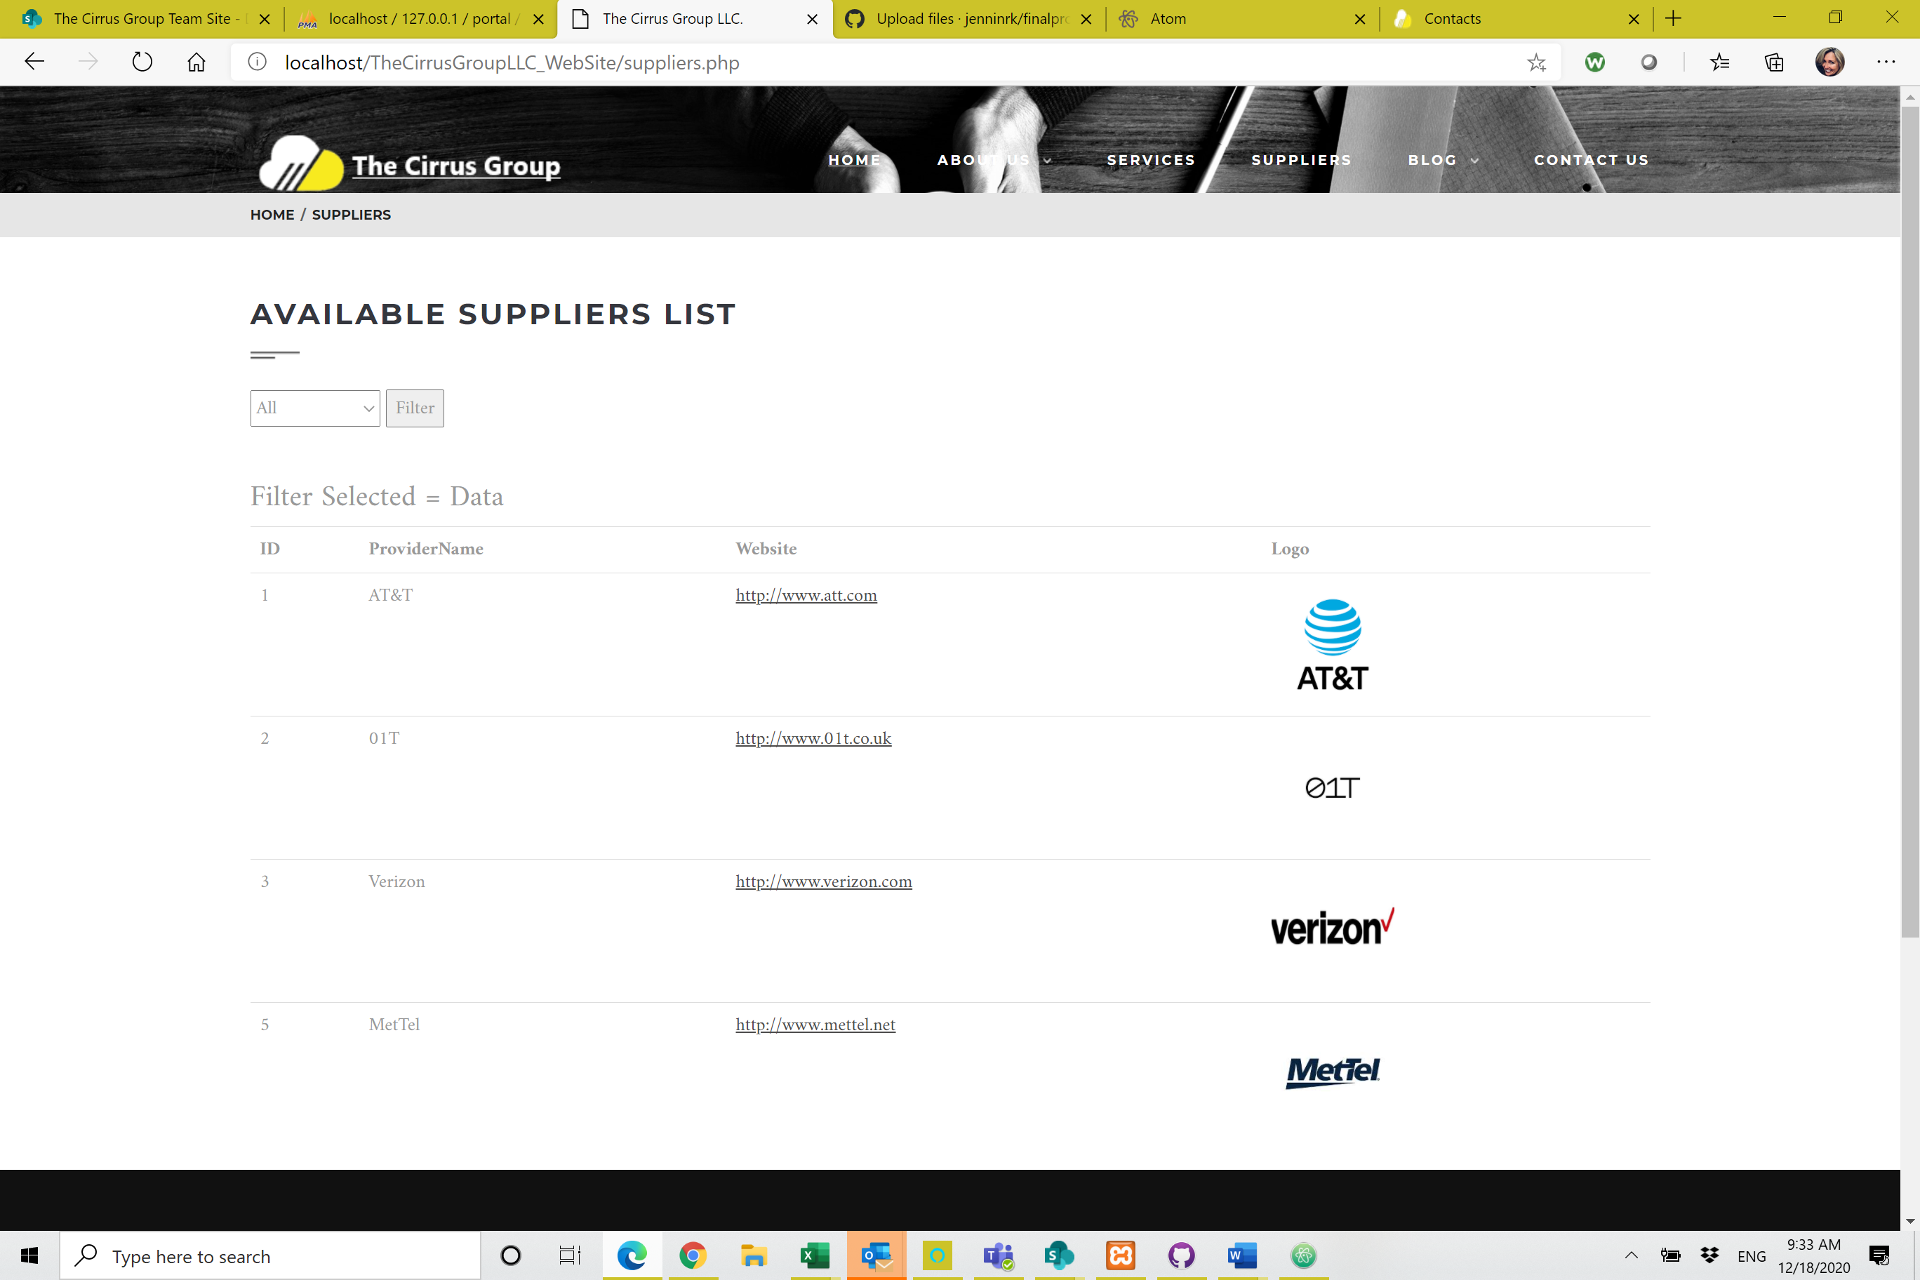

**AVAILABLE SUPPLIER MATRIX – UNDERLYING DATABASE**

Here we show a cut of the underlying table used as the database from which to pull attributes.

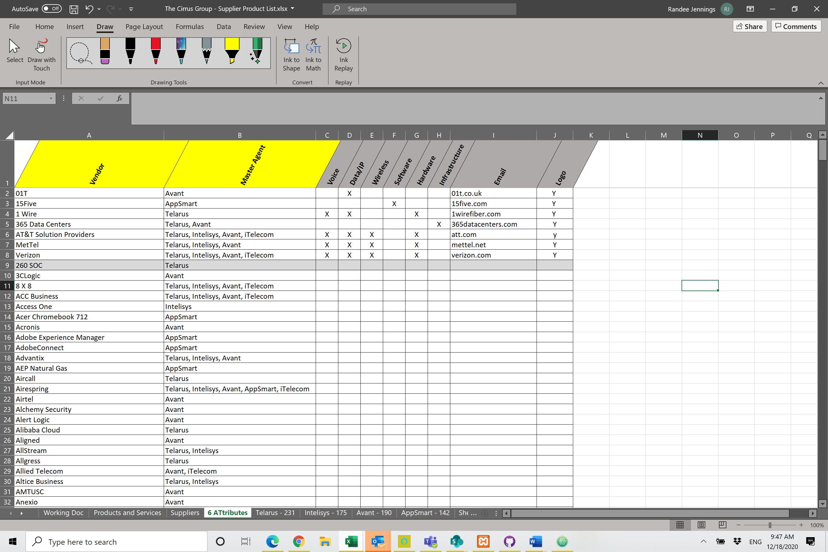

**AVAILABLE SUPPLIER MATRIX – PHP ADMIN**

Here is the database and table I created to warehouse the table above in PHP Admin:

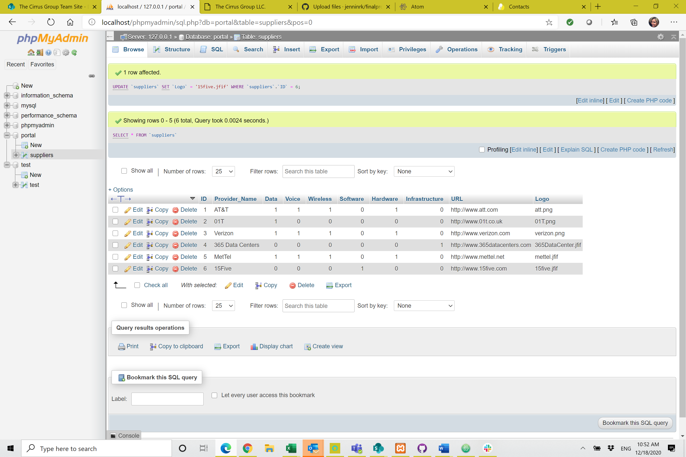

**AVAILABLE SUPPLIER MATRIX – PHP CODE**

Here is the underlying PHP code that creates the table visible in screenshot above:

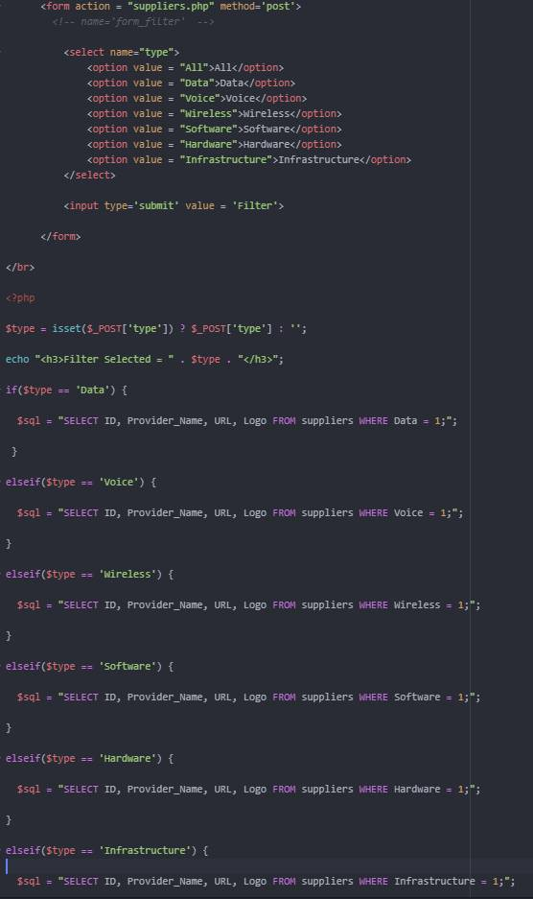

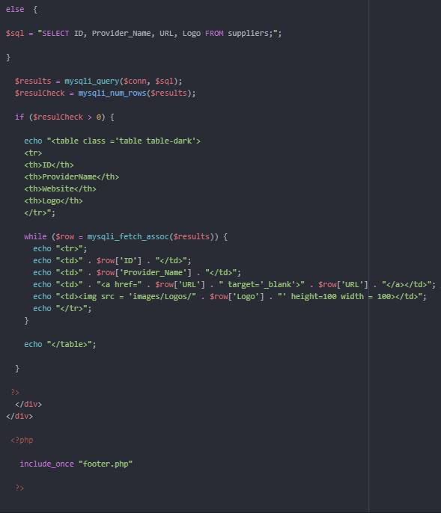

**PROFESSIONAL SERVICES**

This is the list of professional services we offer to wrap the desired services with the needed professional services to ensure a migration to a new platform is conducted with minimal disruption to ongoing operations, and with minimal dependence on scarce client resources/headcount.

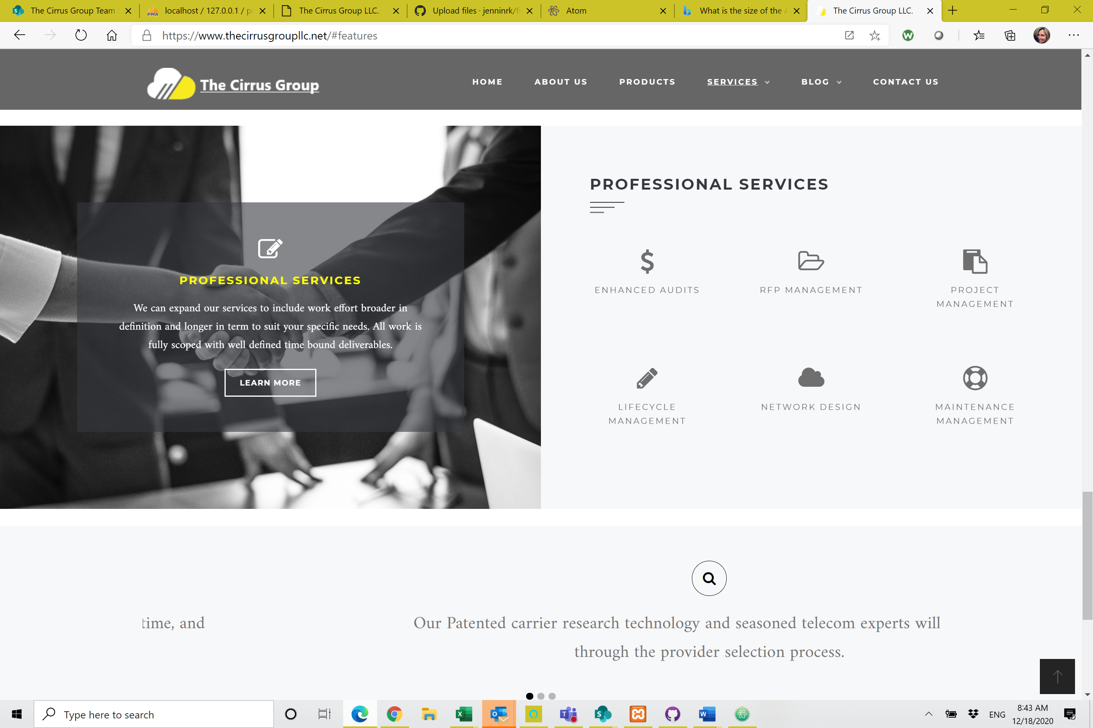

**BLOG**

This page will contain links to You Tubes and White Papers (currently there are 36) for applications sold across various industries using various products and services. This will further communicate to the prospective client not only how Cirrus works, but quantified and accretive benefits realized by each client.

Currently this link on the website takes you to a YouTube video for The Cirrus Group. The white papers are not yet added, but will be by January, 2021.

**CONTACT US**

This is how prospective clients can reach out for an engagement. Next I plan to write a ticketing system so these contact requests can be gathered, tracked and managed.

